**WW BA Homework Assignment**

**Please send answers back to** [**alazar@theknotww.com**](mailto:alazar@theknotww.com) **and cc** [**cramirez@theknotww.com**](mailto:cramirez@theknotww.com)

**SQL Questions**

Given the following schema in Northwind, write a query to

1. Find the order ID and date of the last discontinued item sold.
2. Find the shipped region where we sold (and shipped) the most items by quantity.
3. Find the average order size by a customer’s region.

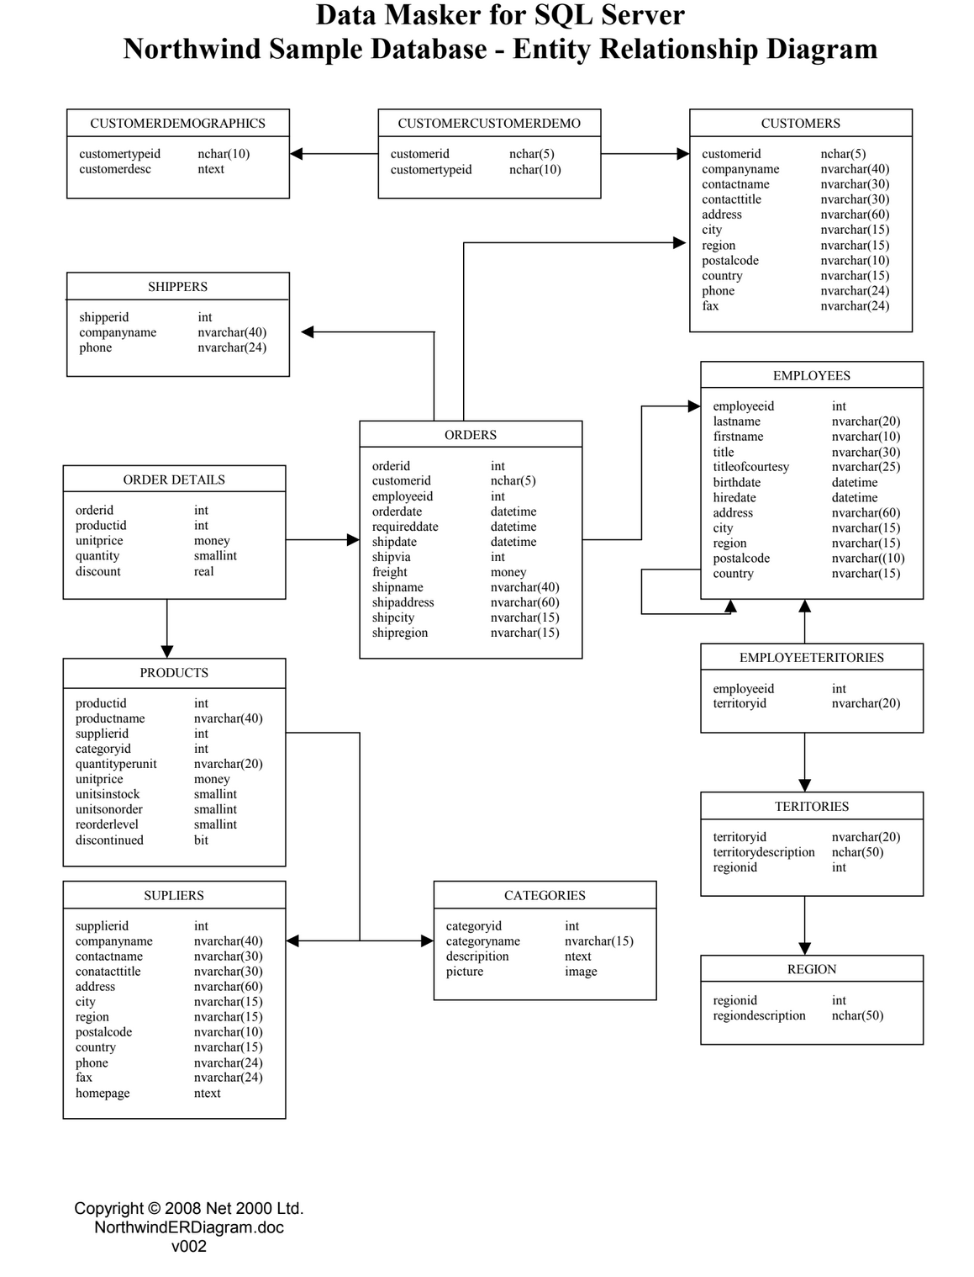

1. Given these 2 tables below find all the people who never placed an order but linked to someone who did (eg: Doug never placed an order but has a friend Sam who has. I want to market to Doug to have him buy something).

Note: the below tables do not show all the rows, this is only an example

[person_link_person]

|  |  |
| --- | --- |
| **person_id** | **linked_person_id** |
| 1 | 2 |
| 1 | 3 |
| 2 | 1 |
| 3 | 1 |
| 3 | 4 |
| 3 | 5 |
| 4 | 3 |
| 5 | 3 |
| 6 | 4 |
| ... | ... |

[orders]

|  |  |
| --- | --- |
| **order_id** | **person_id** |
| 1001 | 1 |
| 1002 | 1 |
| 1003 | 3 |
| 1004 | 5 |
| ... | ... |

1. Create a query to provide a histogram of the number of x people who made y number of orders. Anyone with > 10 orders should be grouped into a “10+” bucket.

-1. Find the order ID and date of the last discontinued item sold.

select top 1 o.orderid, o.orderdate

from orders o

inner join orderdetails od on o.orderid = od.orderid

inner join projects p on p.productid = od.productid

where p.discontinued = 1

order by o.orderdate desc

--2. Find the shipped region where we sold (and shipped) the most items by quantity.

select o.shipregion

from orders o

inner join orderdetails od on o.orderid = od.orderid

group by o.shipregion

order by sum(od.quantity) desc,count(distinct od.productid) desc

--3. Find the average order size by a customer’s region.

select c.region, avg(ord_quantity) avg_size

from

(

select o.orderid,sum(od.quantity) ord_quantity

from orders o

inner join orderdetails od on o.orderid = od.orderid

group by o.order_id

)ord

inner join orders o on o.orderid = ord.orderid

inner join customers c on c.customerid = o.customerid

group by c.region

--4. Given these 2 tables below find all the people who never placed an order but linked to someone who did

-- (eg: Doug never placed an order but has a friend Sam who has. I want to market to Doug to have him buy something).

-- Note: the below tables do not show all the rows, this is only an example

select distinct noorder.persion_id

from

(

select pp.persion_id, pp.linked_person_id

from person_link_person pp

left join orders o on pp.person_id = o.persion_id

where o.order_id is null

)noorder

inner join orders o on noorder.linked_person_id = o.persion_id

--5. Create a query to provide a histogram of the number of x people who made y number of orders.

--Anyone with > 10 orders should be grouped into a “10+” bucket.

select case when count(order_id) > 10 then person_id else '' end as '10+ Bucket',

case when count(order_id) = 10 then person_id else '' end as '10 Bucket' ,

case when count(order_id) = 9 then person_id else '' end as '9 Bucket',

case when count(order_id) = 8 then person_id else '' end as '8 Bucket',

case when count(order_id) = 7 then person_id else '' end as '7 Bucket',

case when count(order_id) = 6 then person_id else '' end as '6 Bucket',

case when count(order_id) = 5 then person_id else '' end as '5 Bucket',

case when count(order_id) = 4 then person_id else '' end as '4 Bucket',

case when count(order_id) = 3 then person_id else '' end as '3 Bucket',

case when count(order_id) = 2 then person_id else '' end as '2 Bucket',

case when count(order_id) = 1 then person_id else '' end as '1 Bucket'

from orders

group by person_id